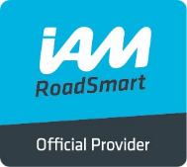
Issue 2 8 May 2018
INCIDENT REPORT

The purpose of this report is to record details of any riding incidents on WHAM events.
Each completed form will be reviewed by the WHAM Committee to agree any improvement actions necessary.

WHAM Member(s) involved
Machine Details
Date & Time of incident
3rd party involvement
Emergency Services involvement
Incident location
Weather and road condition
Probable cause
Evident injuries / damage
Suggested improvement actions
Observer filing report

